***Grade 6***

***Worksheet 6***

***Q: Simplify.***

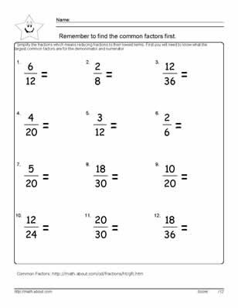

***Grade 6***

***Worksheet 7***

***Q: Find the square root of the following.***

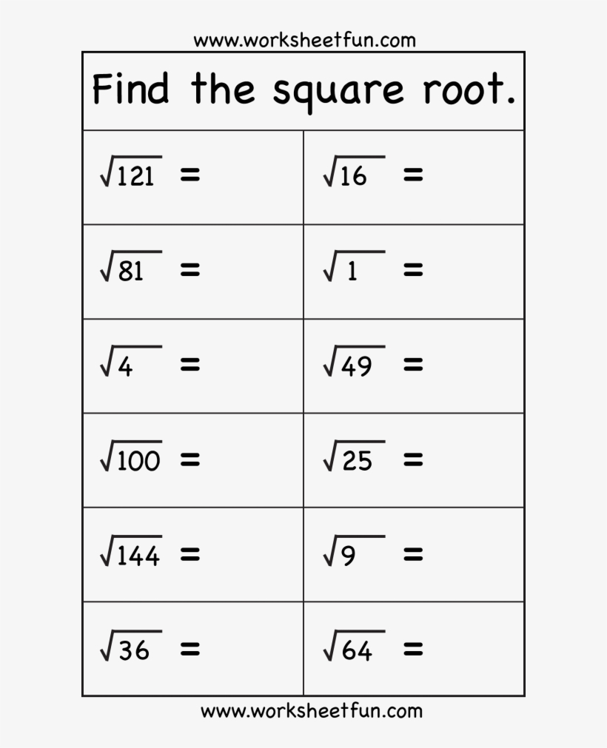

***Grade 6***

***Worksheet 8***

***Q:Simplify the following.***

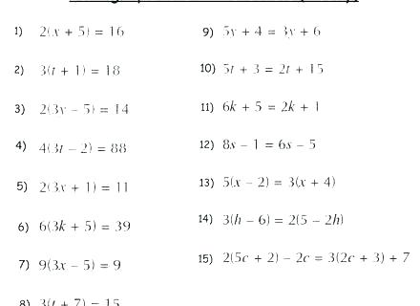

***Grade 6***

***Worksheet 9***

***Q: Simplify the following.***

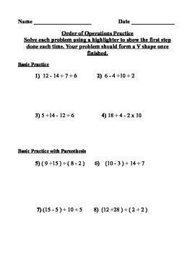

***Grade 6***

***Worksheet 10***

***Q: Solve it.***

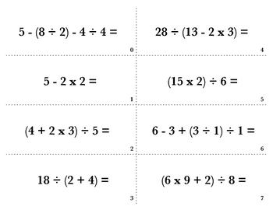

s